Retailync Software Change Requests

- Product list. (Product All Products)
All the products are in alphabetical order, that’s why they are mixed up. 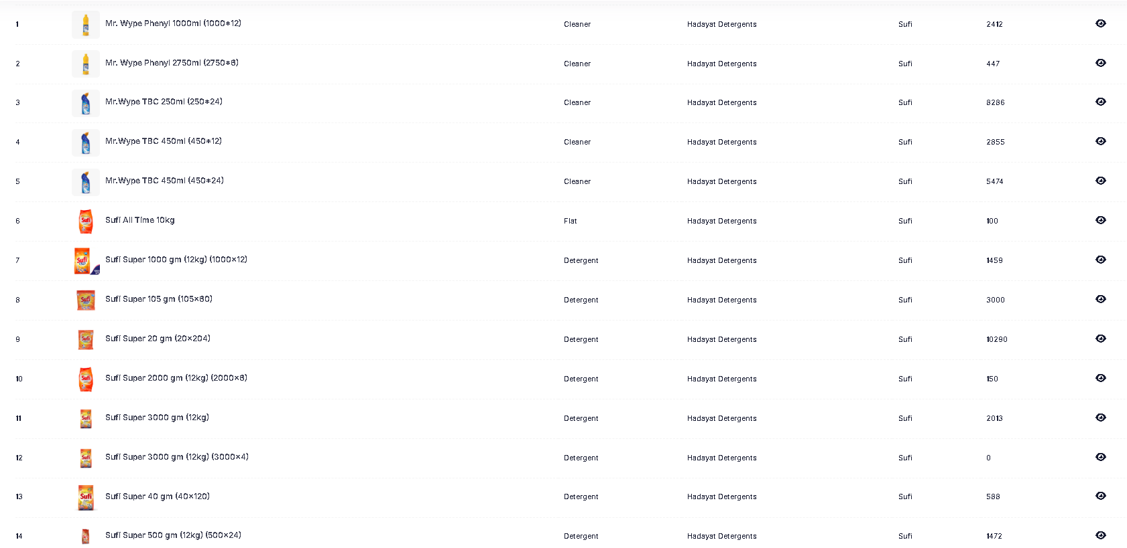
Please ensure that the stock report in the software follow the exact product sequence that has been provided. They should be in the following order:
- Sufi Super
  - Sufi Super 20g
  - Sufi Super 40g
  - Sufi Super 105g
  - Sufi Super 500g
  - Sufi Super 1000g
  - Sufi Super 2000g
  - Sufi Super 3000g
- Twin 2x
  - Twin 2x 500g
  - Twin 2x 1000g
- Twin Economy
  - Twin Economy 42g
  - Twin Economy 70g
  - Twin Economy 220g
  - Twin Economy 423g
  - Twin Economy 1000g
- Bulk
  - Twin Economy 5kg
  - Twin Economy 5kg Lemon
  - All Time 10kg
- Cleaner
  - Mr. Wype TBC 250ml (250*24)
  - Mr. Wype TBC 450ml (450*12)
  - Mr. Wype TBC 450ml (450*24)
  - Mr. Wype Phenyl 1000ml (1000*12)
  - Mr. Wype Phenyl 2750ml (2750*6)

- Stock Report Generation.
The stock report that is being generated does not include the columns for cartons and total value of the stock. These columns must be added. Additionally, the overall format of the stock report is very basic and needs to be improved.

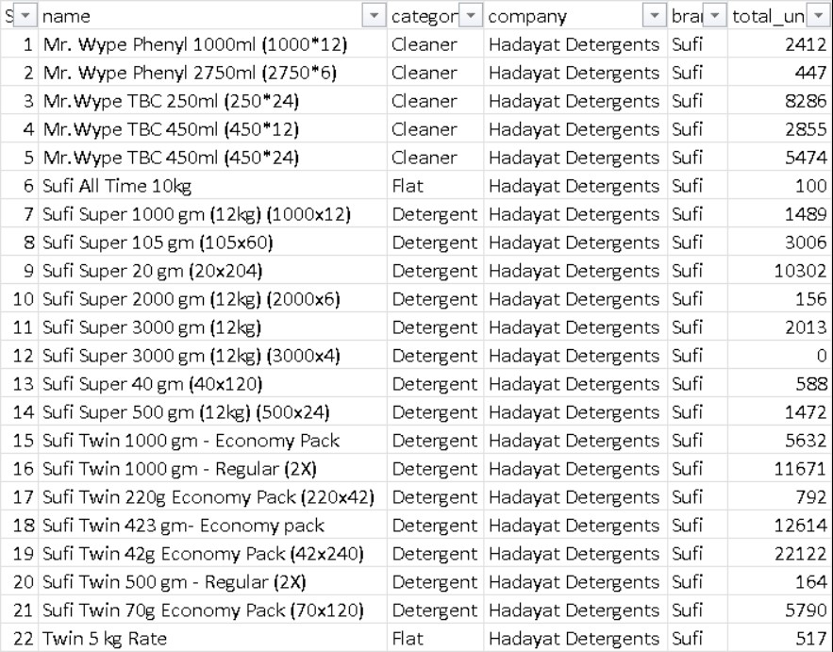

Also, please ensure that the stock reports generated by the software follow the exact product sequence that has been provided. The report should not be sorted alphabetically but should reflect the predefined sequence.

- View Load Form
After closing the load form, the system displays the total issued stock, delivered stock, and undelivered stock. A difference appears between the total issued and delivered stock due to discount adjustments. Kindly update the system to clearly mention that this variance is caused by the discount, so it does not create confusion.
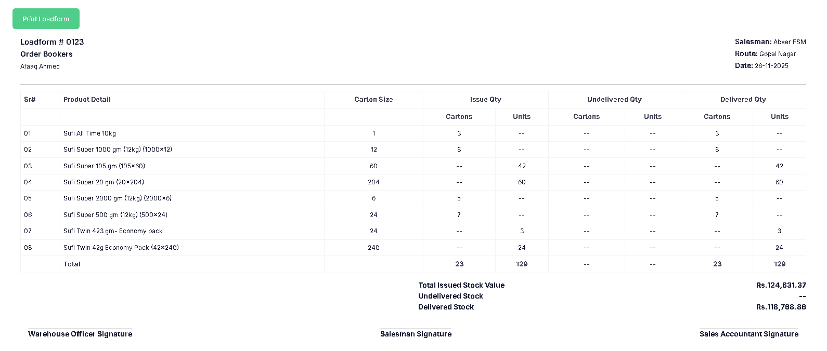

Some Quarries from the KPOs
- Can one load form be created for two persons?
At Latif Traders, there are 6 order bookers and 3 salesmen. One salesman takes the load for 2 bookers.

Query: Is it possible for the system to generate a single load form for two persons (for example, one salesman managing the load for two order bookers)?

- How should returned or damaged stock be handled in the software?
When old or damaged stock is returned from the market:

Query: What is the proper process to record and manage old / damaged stock returned from the market in the software? Should it be adjusted against current stock, treated as a separate return, or handled via a credit/debit note?

- How to manage additional trade discounts based on order volume?
  - For Twin Economy, orders above 10,000+ qualify for 1.5% extra discount.
  - For Sufi Super, orders above 10,000+ qualify for 2% extra discount.
  - This discount is offered by the order booker in the market and later the distributor claimed it from the company at month-end.
Query: How should the software handle additional trade discounts based on order value? Specifically, Sufi Super 10,000+ with 2% discount and Twin Economy 10,000+ with 1.5% discount, where the discount is issued in the market and later claimed from the company at month-end.
- Reports Formatting & Product Sequence
- All software-generated reports are currently in alphabetical order with a very basic layout.
- Query: Improve the format of all reports to make them more professional and comprehensive. Ensure product listings follow the predefined sequence (as provided), not alphabetical order?

- The report format must include the following fields

- In the stock report, the value of each product should be displayed separately. Additionally, the report format must include the following fields:
  - Total Value of the stocks
  - Cartons
  - Prices
  - Single Item Value

